****14.Arduino UNO platform ------- bluetooth_control****

****1)Introduction of experimental****

In this experiment, we control car by Bluetooth App by ****Android or iOS****Mobile phone. The mobile phone sends commands through the serial port to control the advance, backward, turn left, turn right , stop, any angle control of the servo, out fire, whistle, speed of robot car.

At the same time, the status of various sensors on the robot car and the distance measured by the ultrasonic wave are displayed in real time on the Bluetooth APP interface by the serial port.

****2)Experimental Steps****

2.1) Android users scan the following QR code by browser or search "YahboomRobot" in Play Store to download APP;

iOS users scan the following QR code by camera or search "YahboomRobot" in App Store to download APP.

**As shown in figure below.**

!!Note:Because the software is relatively large, the download takes a certain amount of time, please be patient.

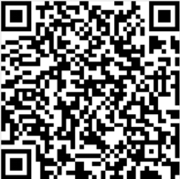

**Note:During installation, If you find any prompts on your phone (for example: location permissions of your phone). You must select "Yes".**

2.2) After the APP is installed, open the Bluetooth of the your phone, open the power switch of the Tank, the red indicator of the Bluetooth module keeps flashing.

2.3) Then, open the YahboomRobot APK. You will see the APK interface and we need to click on the top left corner of the APK to select the device as shown below.

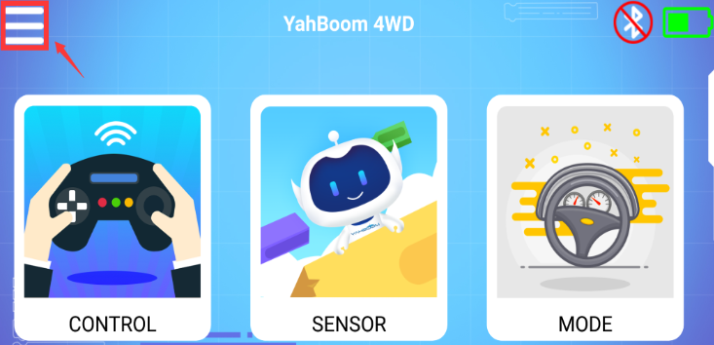

2.4) Select 【G1 Tank】to enter the remote control interface, as shown below:

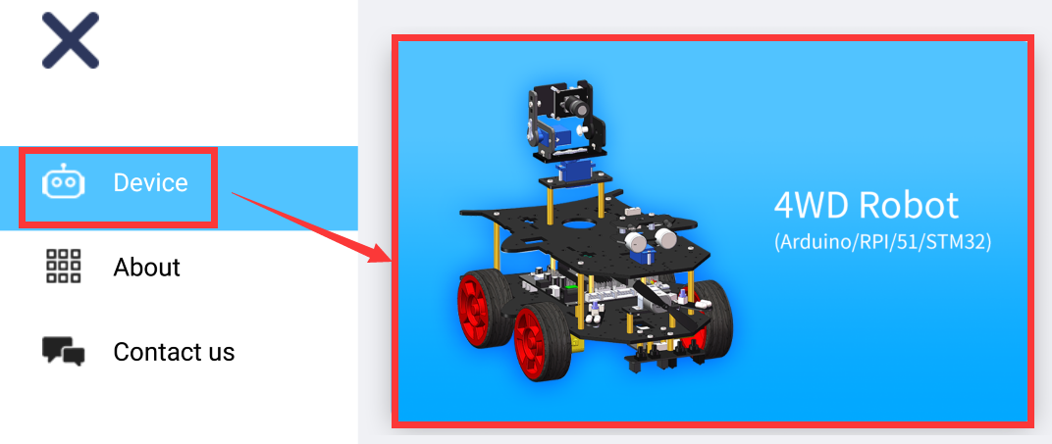

2.5) You will this interface as shown below. Click on the top right corner of the APK to connect bluetooth.

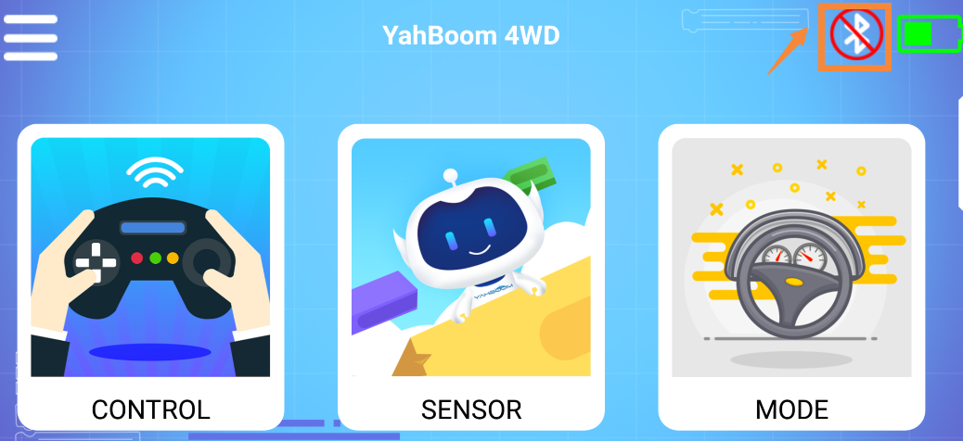

2.6) You can see bluetooth signal. Wait patiently, the phone will automatically connect to the Bluetooth near the car.

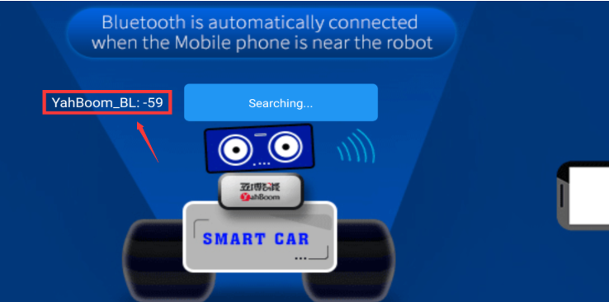

2.7) Bluetooth can be successfully connected, and the APP will enter the interface as shown below. At the same time, the red indicator of the Bluetooth module will be keep on. You need to click”OK”.

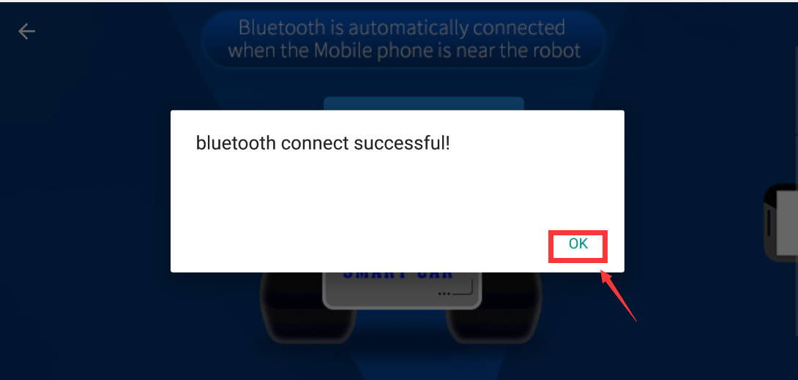

You will enter the interface as shown below.

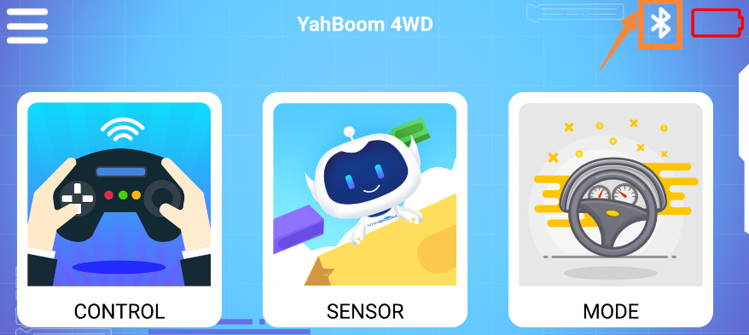

2.8)Click “CONTROL” to enter interface as shown below. Wait for the ultrasonic data to change, it prove that Bluetooth starts to transmit data normally. You can start to control the car.

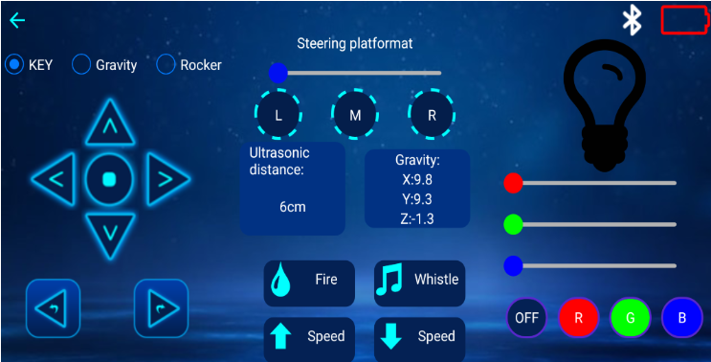

2.9) Click “ SENSOR” to enter interface as shown below.

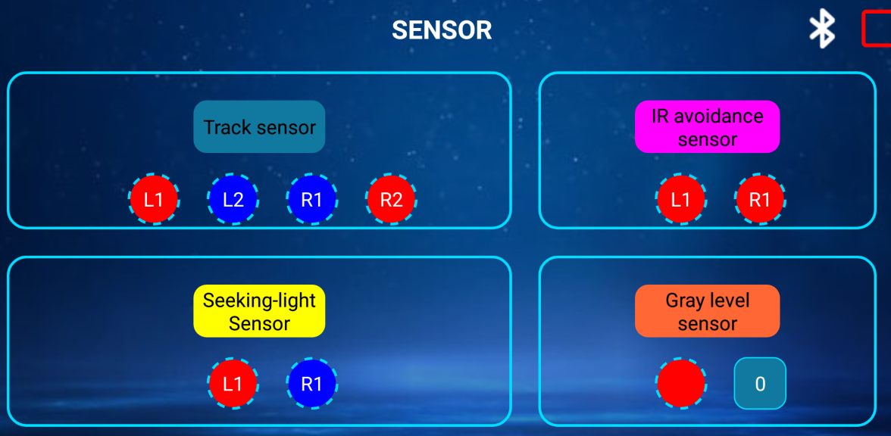

2.10) Click “ MODE” to enter interface as shown below.

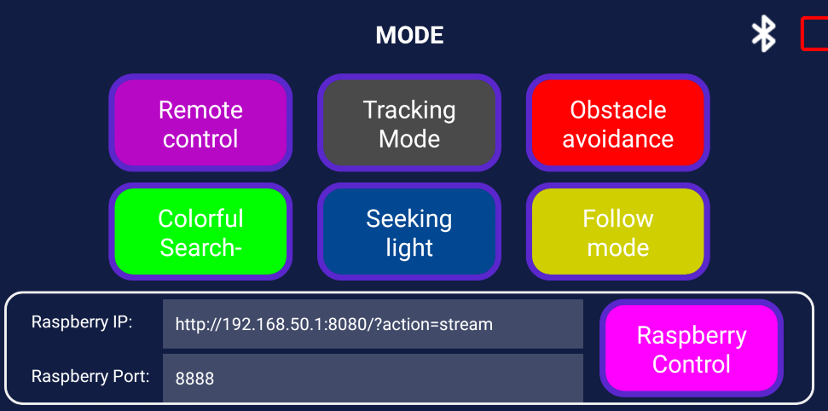

You need to pay attention to the points, otherwise the Bluetooth remote control function will have problems.

**Note:**

****(1)The robot Tank needs to have enough voltage to work properly. Please refer to the following figure for the charging method and battery usage:****

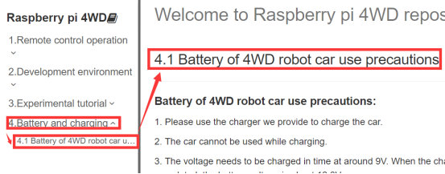

****(2)The Bluetooth module needs to be properly inserted into the expansion board of the Tank. As shown in the figure below.****

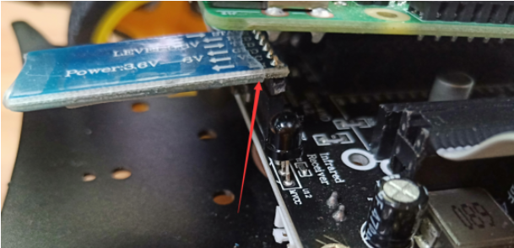

****(3)51/Arduino Download Switch on the expansion board must be set to [OFF]. As shown in the figure below.****

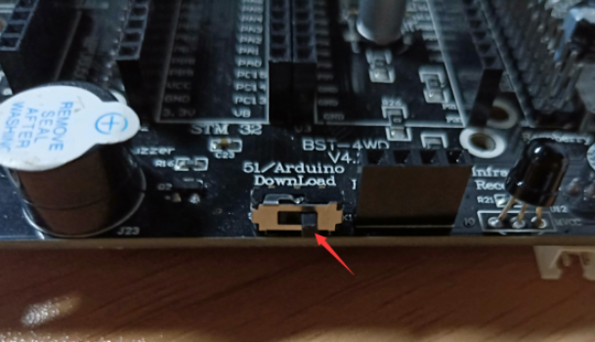

1. **The ultrasonic module must be inserted. As shown in the figure below.**

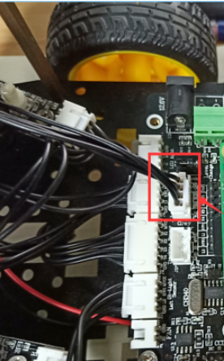

Please read our manual for introductions of Bluetooth remote control interface.

****3) About the code****

****Note: During the upload process, you need to unplug the Bluetooth module.****

3.1) We need to open the code of this experiment:****bluetooth_control.ino****, click“****√****” under the menu bar to compile the code, and wait for the word "****Done compiling**** " in the lower right corner, as shown in the figure below.

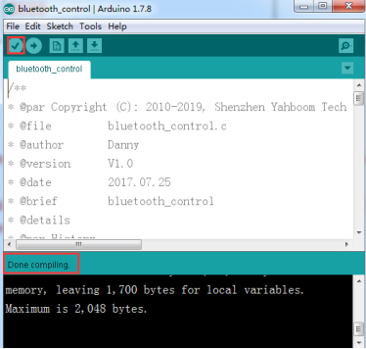

3.1) In the menu bar of Arduino IDE, we need to select 【Tools】---【Port】--- selecting the port that the serial number displayed by the device manager just now, as shown in the figure below.

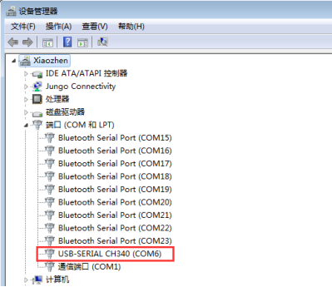

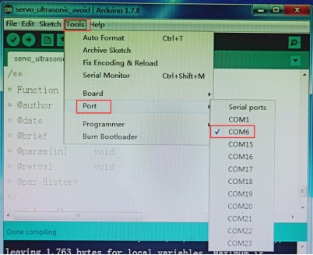

3.1) After the selection is completed, you need to click “****→****”under the menu bar to upload the code to the Arduino UNO board. When the word “****Done uploading****” appears in the lower left corner, the code has been successfully uploaded to the Arduino UNO board, as shown in the figure below.

